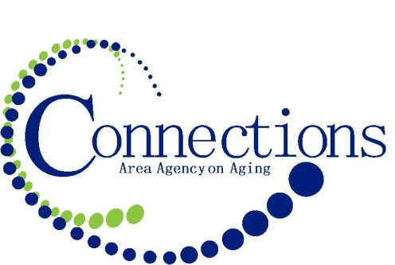
FOR IMMEDIATE RELEASE

Contact: Chris Kuchta
Community Relations Coordinator
800-432-9209 x 2013
ckuchta@connectionsaaa.org

Join Elevate Aging Statewide Conversations August 4

Council Bluffs, Iowa (July 16, 2016) – Iowans are living longer than ever before, with one out of every five residents now aged 60 or older. That number is expected to grow over the next few decades, with the vast majority of individuals stating they would prefer to age in place, in their homes and communities of choice. To ensure that option is a viable one, a comprehensive network of long-term supports and services will have to be available statewide, and older Iowans will need to know how to access those resources.

Are Iowa communities equipped to offer the wide range of services aging individuals will need to maintain their long-term independence? Do older Iowans and their families know what types of services they need and which ones are available locally? And how will Iowa adapt to ensure its aging population will be able to maintain the highest quality of life possible?

Those questions and others will be discussed during a special statewide event when Connections Area Agency on Aging partners with the Elevate Aging Collaborative to present “Join the Conversation: Iowa Dialogue on Helping Older Adults Maintain the Highest Quality of Life Possible” on Thursday, August 4, from 10 a.m. to noon. Experience information sharing, discussion on developing actions and issues related to aging Iowans, and idea generation on how to get involved to make Iowa a better place to age.

With community conversations taking place in Cedar Rapids, Council Bluffs, Davenport, Des Moines, Mason City, and Waterloo, “Join the Conversation” aims to continue a statewide discussion about issues like the changing dynamics between generations; the challenges of caregiving; the financial considerations of elder care; and the realities of aging, both physical and mental. As Iowans share their thoughts, concerns, opinions, and ideas, they will be documented and shared with all Iowans and, in particular, policymakers and Iowa leaders.

“We are pleased to host a continuing dialogue in the Connections Area Agency on Aging region. The conversations are a great way to learn about aging challenges and services available for support. A person can never plan too far ahead. It’s also a great forum to express concerns and ideas. The results will be shared with both agencies and elected officials to guide policy changes for our state,” says Barb Morrison, CEO of Connections Area Agency on Aging.

The non-partisan event is free and open to the public. For additional information, call LifeLong™ Links at 866.468.7887.

SIDEBAR:

The Iowa Area Agencies on Aging are proud to host the statewide community conversations for “Join the Conversation: Iowa Dialogue on Helping Older Adults Maintain the Highest Quality of Life Possible” on Thursday, August 4 from 10 a.m. to noon. The event is free and open to the public. For additional information, call LifeLong Links™ at 866.468.7887.

Cedar Rapids
(Hosted by Heritage Area Agency on Aging)
Kirkwood Continuing Education and Training Center
101 50th Avenue SW Cedar Rapids, IA 52404
6301 Kirkwood Blvd. SW
Cedar Rapids, IA 52406

Council Bluffs
(Hosted by Connections Area Agency on Aging)
Connections Area Agency on Aging
300 W. Broadway, Suite 240
Council Bluffs, IA 51503

Davenport
(Hosted by Milestones Area Agency on Aging)
Milestones Area Agency on Aging
935 E. 53rd Street
Davenport, IA 52807

Mason City
(Hosted by Elderbridge Area Agency on Aging)
Elderbridge Agency on Aging
22 N. Georgia, Suite 216
Mason City, IA 50401

Waterloo
(Hosted by Northeast Iowa Area Agency on Aging)
Northeast Iowa Area Agency on Aging
2101 Kimball Avenue, Suite 320
Waterloo, IA 50702

Des Moines
(Hosted by Aging Resources of Central Iowa)
Des Moines Botanical Center
909 Robert D. Ray Drive
Des Moines, IA 50309

###

Connections Area Agency on Aging is one of six Area Agencies on Aging in Iowa, and part of a nationwide network of Area Agencies on Aging. With a mission to enhance the quality of life for elders in our service area through education, planning and coordination of services, Connections AAA provides information and services for 20 counties in western and southwestern Iowa. Connections AAA is also a part of Iowa’s LifeLong™ Links, serving seniors, caregivers, veterans, and persons with disabilities, especially accessing the services they need to remain independent within their communities.

The Elevate Aging Collaborative is a group of advocacy organizations focused on aging and caregiving issues. Their goal is to help ensure Iowans are informed about, prepared for, and engaged in addressing the challenges of growing older. Members include AARP Iowa, Alzheimer’s Association, The Hale Group, Iowa Alliance for Retired Americans, Iowa Association of Area Agencies on Aging, Iowa CareGivers, Jewish Family Services, and Older Iowans Legislature. Technical assistance is provided by the Office of the State Long-Term Care Ombudsman.

