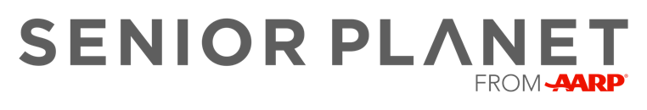

Staying Safe Online Workshop

Date: Monday, November 21, 2022
Time: 2:00 – 3:30 pm
Location: Leon Public Library
200 W. 1st Street
Leon, Iowa

This hands-on workshop reviews important tips for keeping your personal information safe while enjoying the benefits of the internet. Learn how to recognize suspicious emails and what to do when confronted with online scams.

Sign Up Today!
Call: 800-432-9209 Ext. 8710
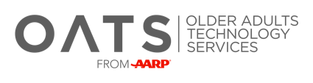
Email: ncorderman@connectionsaaa.org

