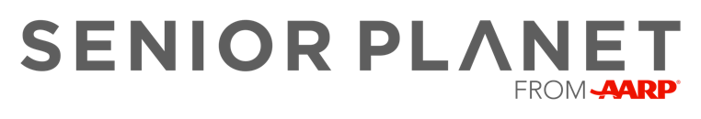

Staying Safe Online Workshop

Date: Thursday, September 22, 2022
Time: 3:00 - 4:30 pm
Location: Gibson Memorial Library
200 W. Howard Street
Creston, Iowa

This hands-on workshop reviews important tips for keeping your personal information safe while enjoying the benefits of the internet. Learn how to recognize suspicious emails and what to do when confronted with online scams.

Sign Up Today!
Call: 800-432-9209 Ext. 8710
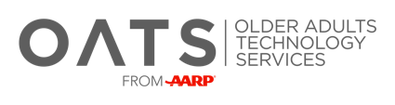
Email: ncorderman@connectionsaaa.org

