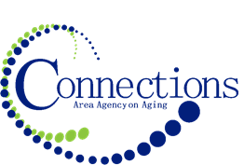

CONNECTIONS AREA AGENCY on AGING
BOARD MEETING
Via Zoom
Agenda

DATE: Wednesday, November 30, 2022
TIME: 11:00AM – 12:30 PM
PLACE: Zoom

ITEM ACTION
I. Call To Order – Kelly Butts-Elston
A. Roll Call - Kelly Butts-Elston
B. Recognition of Visitors
C. Approval of October Minutes – Approve/Amend Motion to Approve
D. Agenda – Approve/Amend Motion to Approve

II. Reports
- Mission Moment Kelly Butts-Elston
- Advisory Council Report Arlene Schwartz / Aubury Krueger Kutchara
- C.E.O. Report Kelly Butts-Elston
- Division Reports

III. Business Requiring Action
- Fiscal Report Motion to Accept and File
- Approval of Staff Holiday Gift Motion to Approve

IV. Business Requiring No Action
- Annual Board Training: OAA Kelly Butts-Elston

V. Open Forum

VIII. Adjournment

NOTE: If there is anything you want added to the agenda please call or email me kbutts@connectionsaaa.org (712-828-7038 or 712-828-1399) by Nov. 29th and we can add it.

