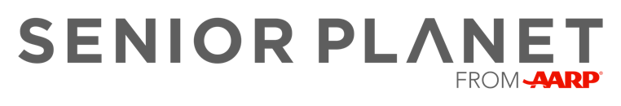

Protecting Your Personal Information Online

Date: Monday, December 5, 2022
Time: 2:00 - 3:30 pm
Location: Leon Public Library
200 W. 1st Street
Leon, Iowa

This presentation will cover the ins and outs of how to protect your personal information online. We’ll cover tips for staying safe in cyberspace, like safe browsing, how to recognize online scams, and when it’s OK – or not – to share your personal information online.

Sign Up Today!
Call: 800-432-9209 Ext. 8710
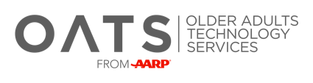
Email: ncorderman@connectionsaaa.org

