Council Bluffs Country Club
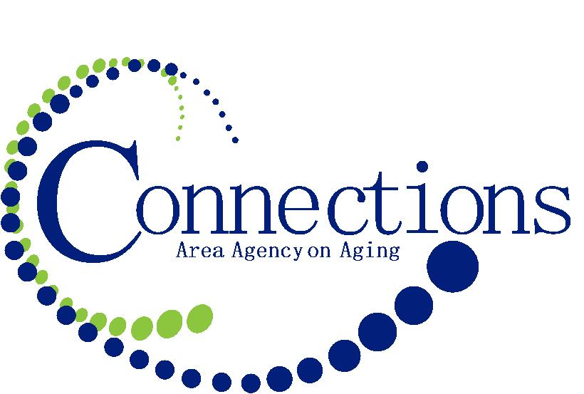
4500 Piute Street
Council Bluffs, IA 51501
September 11,2015

SPONSORSHIP LEVELS FOR THE SENIOR SWING

PLATINUM LEVEL - $2500.00
YOUR NAME IN ALL MEDIA PROMOTIONS * 3 FOURSOMES IN TOURNAMENT * ACCESS TO DISTRIBUTE PROMOTIONAL MATERIALS * VALUED ADVERTISING IN DAILY NONPAREIL * YOUR COMPANY NAME ON FIELD OF PLAY
GOLD SPONSORSHIP - $1000.00
YOUR NAME IN ALL MEDIA PROMOTIONS * 2 FOURSOMES IN TOURNAMENT * ACCESS TO DISTRIBUTE PROMOTIONAL MATERIALS * VALUED ADVERTISING IN DAILY NONPAREIL * HOLE SIGN REPRESENTATION AT EVENT
SILVER SPONSORSHIP - $500.00
FOURSOME IN TOURNAMENT * ACCESS TO DISTRIBUTE PROMOTIONAL MATERIALS * HOLE SIGN REPRESENTATION AT EVENT
HOLE SPONSORSHIP - $150.00
HOLE SIGN REPRESENTATION AT EVENT

I would like to support Connections Area Agency on Aging, Inc. by contributing to your annual fundraising effort. I will be a partner to seniors at the following level:

______PLATINUM ______SILVER

______GOLD ______HOLE

NAME_____________________________________________________

COMPANY_________________________________________________

ADDRESS__________________________________________________
__________________________________________________

PHONE____________________________________________________

_______CHECK ENCLOSED ______PLEASE BILL ME

For questions or concerns, please contact Terri Martin @ Connections AAA
712/328-2540 ext. 1056 or toll free at 800/432-9209
email: tmartin@connectionsaaa.org or mail your completed form to 300 W. Broadway, Suite 240, Council Bluffs 51503

