For Immediate Release: 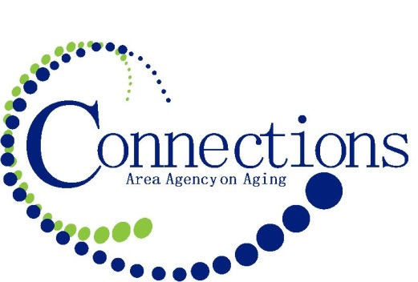
Questions: Chris Kuchta, Community Relations Manager
800-432-9209 ext. 2013

Connections Area Agency on Aging, in collaboration with the Governor’s office and the Iowa Department on Aging, is seeking the public’s support and assistance in identifying Iowa’s centenarians. The Iowa Department on Aging maintains a state registry of Iowa centenarians and they use the registry to invite those individuals who are or will be turning 100 years of age (or older) by Dec. 31, 2015 to this year’s Centenarian Recognition Events. These Centenarian Recognition Events are hosted by Governor Branstad and co-sponsored by the Department on Aging and the Iowa Area Agencies on Aging.

How You Can Help: Connections Area Agency on Aging is asking for assistance from the public to ensure that each eligible centenarian receives an invitation to be honored. If you, a family member or someone in your community is now or will be turning 100 (or older) by December 31, 2015, please encourage or assist them in the registration process.

Criteria:
- Must be 100 years old or older by December 31, 2015
- Primary residence must be in Iowa

To Apply:
The application, which includes an Authorization for Release of Information Form may be obtained online from the Iowa Department on Aging website (www.iowaaging.gov) or may be requested by calling 800-532-3213 or emailing erin.kurth@iowa.gov

To be eligible to participate, completed applications must be received by Aug. 31, 2015 as all centenarians will receive a certificate signed by Governor Branstad, and will be invited to a 2015 Centenarian Recognition Event this fall.

The centenarian or an authorized representative of the centenarian may complete and submit the application.
Mail Completed Applications to:
Iowa Department on Aging – Centenarian Project
510 E. 12th Street, Suite 2
Des Moines, IA 50319-9025

