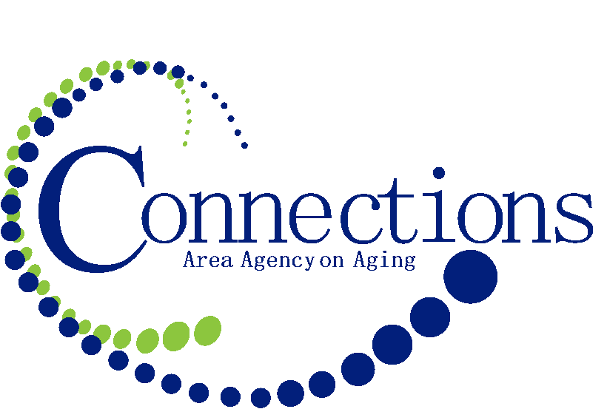
FOR IMMEDIATE RELEASE

Contact: Chris Kuchta
Community Relations Coordinator
800-432-9209
ckuchta@connectionsaaa.org

Join the Conversation: Elevate Aging Coalition to Continue
Statewide Conversations November 17

Council Bluffs, Iowa (October 26, 2015) – Iowans are living longer than ever before, with one out of every five residents now aged 60 or older. That number is expected to grow over the next few decades, with the vast majority of individuals stating they would prefer to age in place, in their homes and communities of choice. To ensure that option is a viable one, a comprehensive network of long-term supports and services will have to be available statewide, and older Iowans will need to know how to access those resources.

Are Iowa communities equipped to offer the wide range of services aging individuals will need to maintain their long-term independence? Do older Iowans and their families know what types of services they need and which ones are available locally? And how will Iowa adapt to ensure its aging population will be able to maintain the highest quality of life possible?

Those questions and others were discussed June 26, 2015 in numerous cities across Iowa. The next conversation will include similar and new topics of discussion during a special statewide event next month when Connections Area Agency on Aging partners with the Elevate Aging Coalition to present “Join the Conversation: Iowa Dialogue on Helping Older Adults Maintain the Highest Quality of Life Possible” on Tuesday, November 17, from 10 a.m. to noon. The location for this event hosted by Connections Area Agency on Aging will be held at The Old Depot in Creston, Iowa, 116 W. Adams Street.

With community conversations taking place in Ames, Cedar Rapids, Creston, Dubuque, Fort Dodge, and Ottumwa, “Join the Conversation” aims to continue a statewide discussion about issues like the changing dynamics between generations; the challenges of caregiving; the financial considerations of elder care; and the realities of aging, both physical and mental. As Iowans share their thoughts, concerns, opinions, and ideas, they will be documented and shared with all Iowans and, in particular, policymakers and Iowa leaders.

“We are pleased to host another dialogue in the Connections Area Agency on Aging region. The conversations are a great way to learn about aging challenges and services available for support. A person can never plan too far ahead. It’s also a great forum to express concerns and ideas. The results will be shared with elected officials to guide policy changes for our state,” says Barb Morrison, CEO of Connections Area Agency on Aging.

Connections Area Agency on Aging is one of six Area Agencies on Aging in Iowa, and part of a nationwide network of Area Agencies on Aging. With a mission to enhance the quality of life for elders in our service area through education, planning and coordination of services, Connections AAA provides information and services for 20 counties in western and southwestern Iowa. Connections AAA is also a part of Iowa’s LifeLong™ Links, serving seniors, caregivers, veterans, and persons with disabilities, especially accessing the services they need to remain independent within their communities.

The event is free and open to the public. For additional information, call LifeLong™ Links at 866.468.7887.

