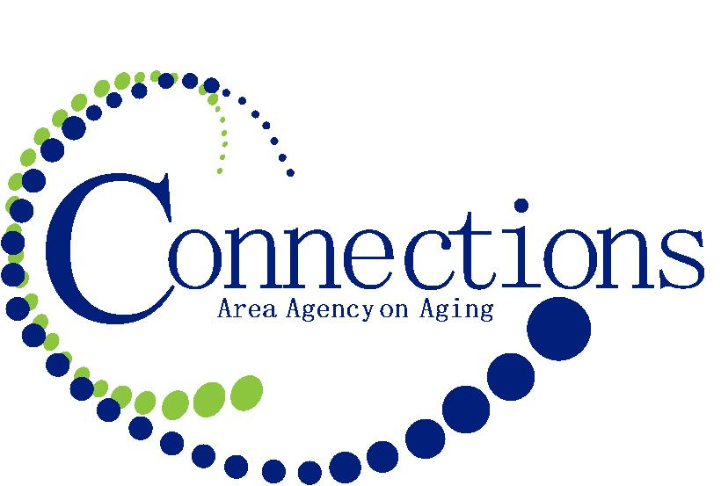
Contact Aubury Krueger  Telephone 1-800-432-9209  Email akrueger@connectionsaaa.org  Website Connectionsaaa.org | FOR IMMEDIATE RELEASE  September 14, 2016

Connections Area Agency on Aging, SOS program to Assist Seniors with Aging in Place

Connections Area Agency on Aging is pleased to announce our grant partnership with Southern Iowa COG Housing Trust Fund, allowing the launch of our Solution Options for Seniors Program (SOS) in the following 7 counties: Adair, Adams, Clarke, Decatur, Ringgold, Taylor and Union.
Iowans are living longer than ever before, with one out of every five residents now aged 60 or older. That number is expected to grow over the next few decades, with the vast majority of individuals stating they would prefer to age in place, in their homes and their community.
The SOS program provides financial assistance for home owners age 60+ experiencing unplanned and unexpected expenses that come with aging in place. The program is designed to provide financial assistance with needed home repairs or modifications not based on income but on financial need. For more information about Connections Area Agency on Aging or our SOS program please call us at 1-800-432-9209.

# # #
If you would like more information about this topic, please contact Aubury Krueger at 1-800-432-9209 or email at akrueger@connectionsaaa.org.

